Patrick Thavornkant

Journalism Duty

Service Learning

Imaging Team Progress

Currently the imaging team has done research into analysis of crop fields. We’ve been developing a program to distinguish which parts of a given field are filled with poor crops in contrast to those with good crops. Our current progress allows us to highlight bad crops by altering their pixel values in an image.

Currently, our program exists in both Java and C++, which is somewhat of a multi-platform support. Our final product aims to be namely in Java, but a C++ build does exist. We’re aiming for Java because it’s free to develop on, and affordability is key when working on this project.

We achieve our results by taking a given image and scanning it as a matrix. We go pixel by pixel and check its’ value to a given threshold (ie, we’re told bad crops in this image are the gray ones, or ‘x’ color, thus we check each pixel for that color) and should they meet that threshold, we change its’ value to something that greatly sticks out in the image so that it is easier to see. Through this method, we can also remove unimportant areas by changing them into background colors.

We can do this with images converted into grayscale, as well as RGB images. We are testing our programs with various types of images and are fine tuning them to more accurately identify bad crops and remove areas of disinterest. We’re working on being able to use HSV and heat map analysis to better our results. Below are samples of our programs in action.

Sample Images:

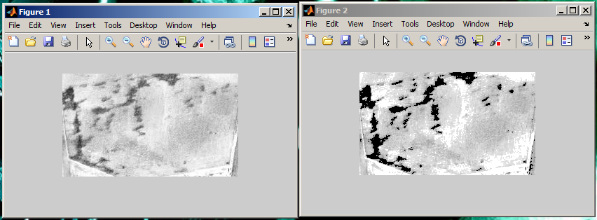

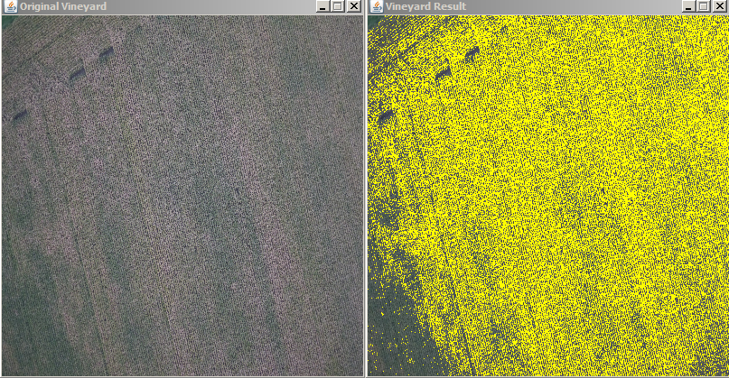

Our analysis can also determine the amount of pixel values altered to be highlighted in order to show what percentage of an image is filled with bad crops. We hope to export relevant data for farmers when their UAVs give them images of their field and our program analyzes them.